**U**nveiling Market Insights: Analyzing Spending Behavior and Identifying Opportunities for Growth

1.INTRODUCTION:

This project , titled “Unveiling Market Insights,” aimed to analyze spending behavior and identify opportunities for growth through the use of Tableau. The primary objective was to gain a comprehensive understanding of consumer spending patterns, market trends, and potential growth areas. Leveraging Tableau’s powerful data visualization capabilities, we sought to transform raw data into actionable insights for strategic decision-making.

**1.1 Overview**

1.1.1 Objectives:

. Analyze spending behavior across different demographic segments.

. Identify key factors influencing consumer purchasing decisions.

. Uncover market trends and anomalies.

. Pinpoint potential areas foe business growth and expansion.

**1.1.2 Methodology:**

. Data collection: Gathered data from diverse source, including transaction records, customer survey, and market research reports.

. Data Cleaning and Integration: Processed and integrated raw dart to create a unified dataset suitable for analysis.

. Data Analysis: Utilized Tableau for in-depth analysis, generating visualizations to explore spending patterns, correlations, and outliers.

. Insights Generation: Derived actionable insights from the analyzed data to inform strategic decision-making.

2. PROBLEM DEFINITION & DESIGN THINKING

2.2 Empathy Map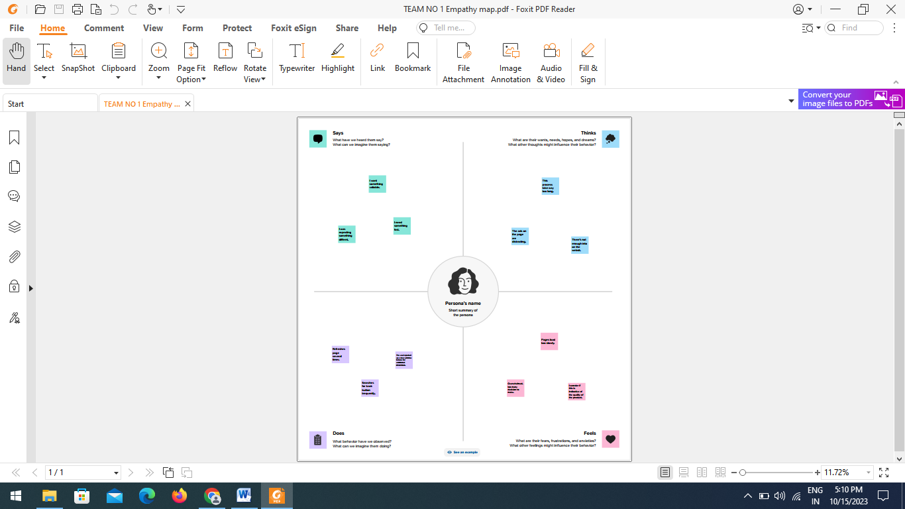

2.2 Ideation & Brainstorming Map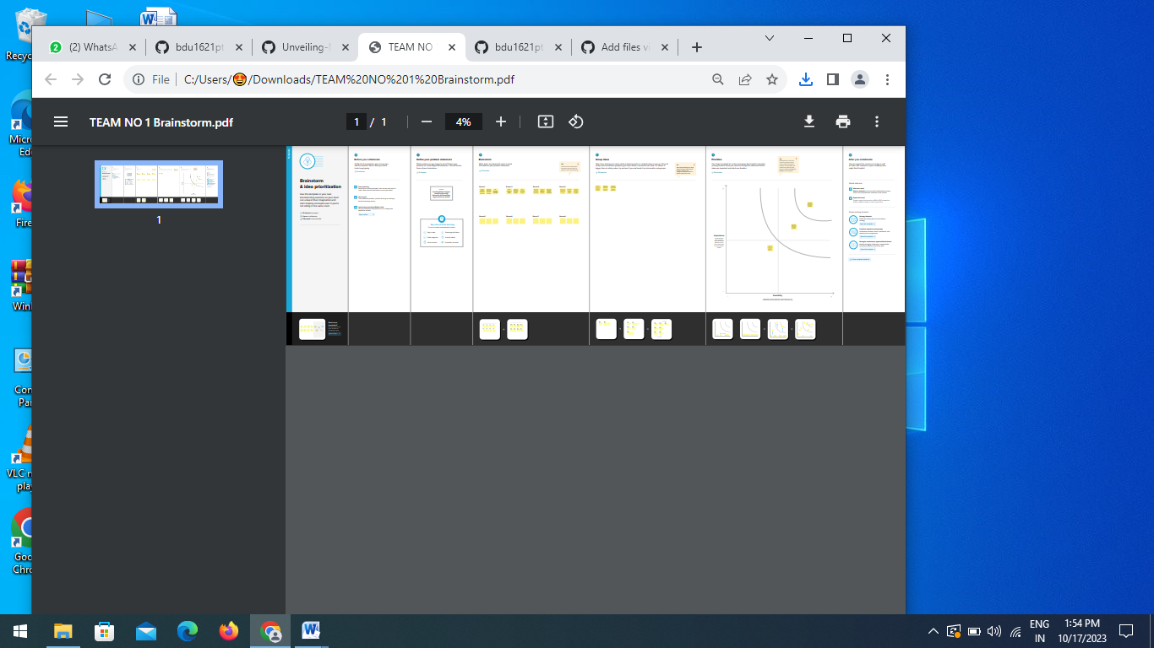

3. RESULT

The available dataset opens the door to an array of unique visual depictions.

Employing diverse visualization techniques like bar charts, line charts, heat maps, scatter plots, pies charts, maps, and others, provides a versatile toolkit for delving into project performance and efficiency. These visual representations serve multiple functions, including performance comparison, temporal trend analysis, and showcasing the distribution and relationships between variables.

3.1 Visualizations

MARKETTING

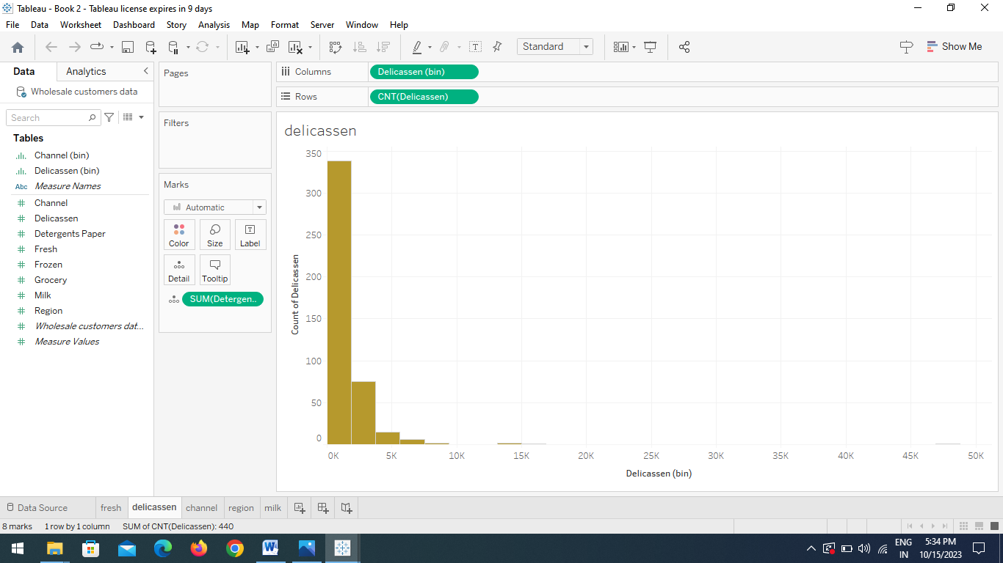

REGION

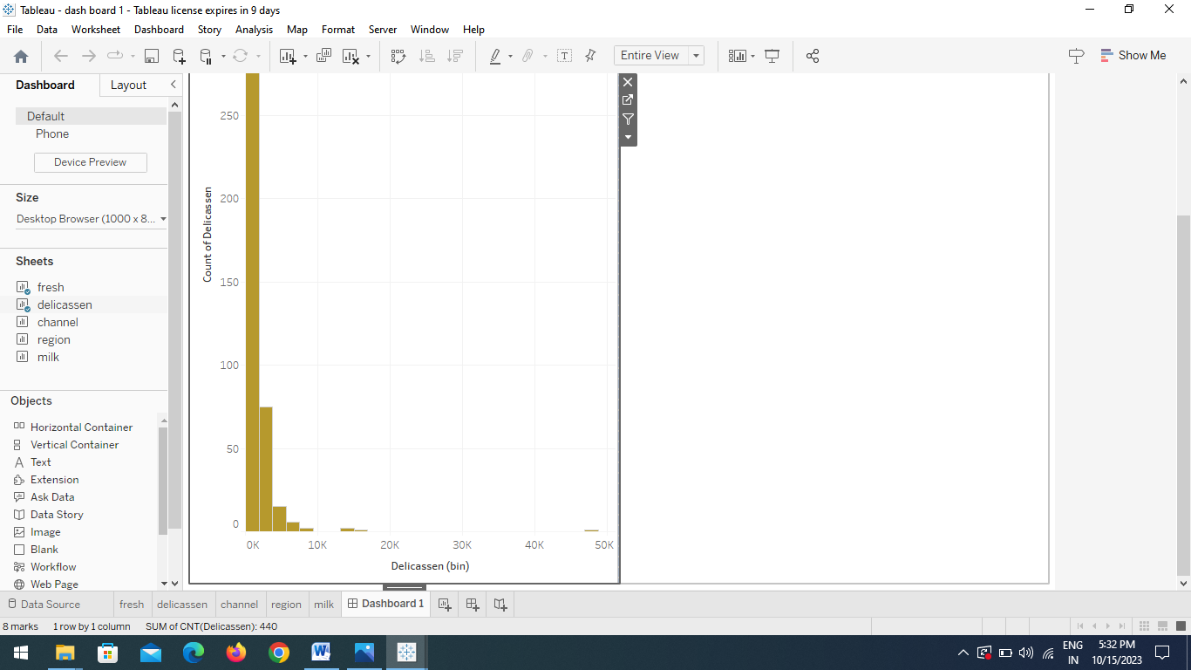

FROZEN

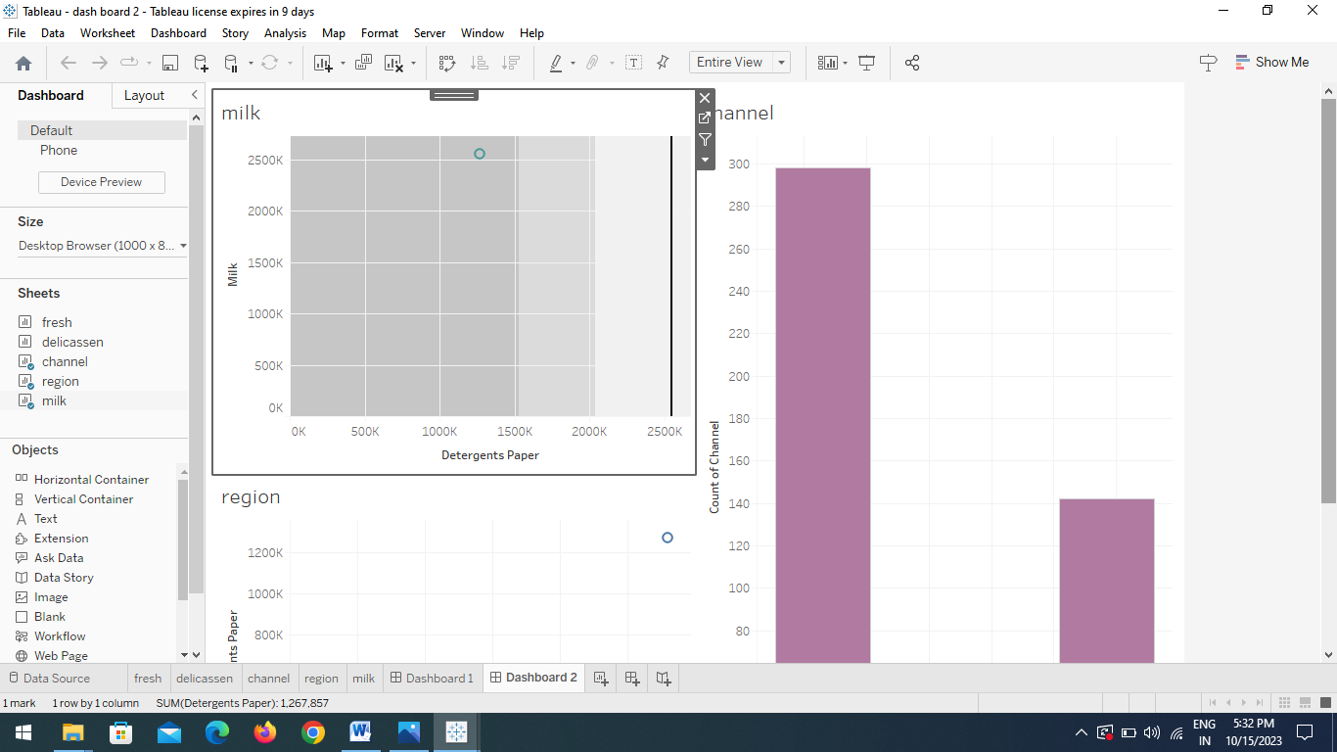

MEASUREMENT

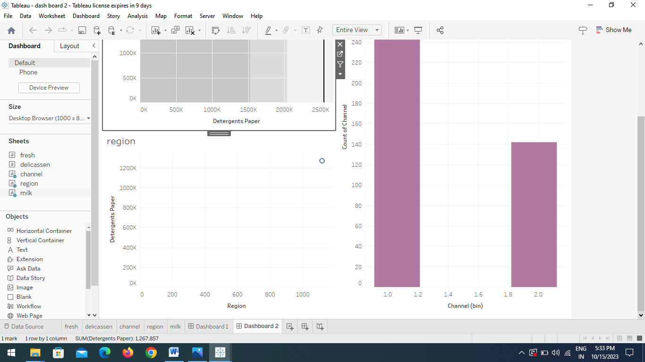

3.2 Dashboard

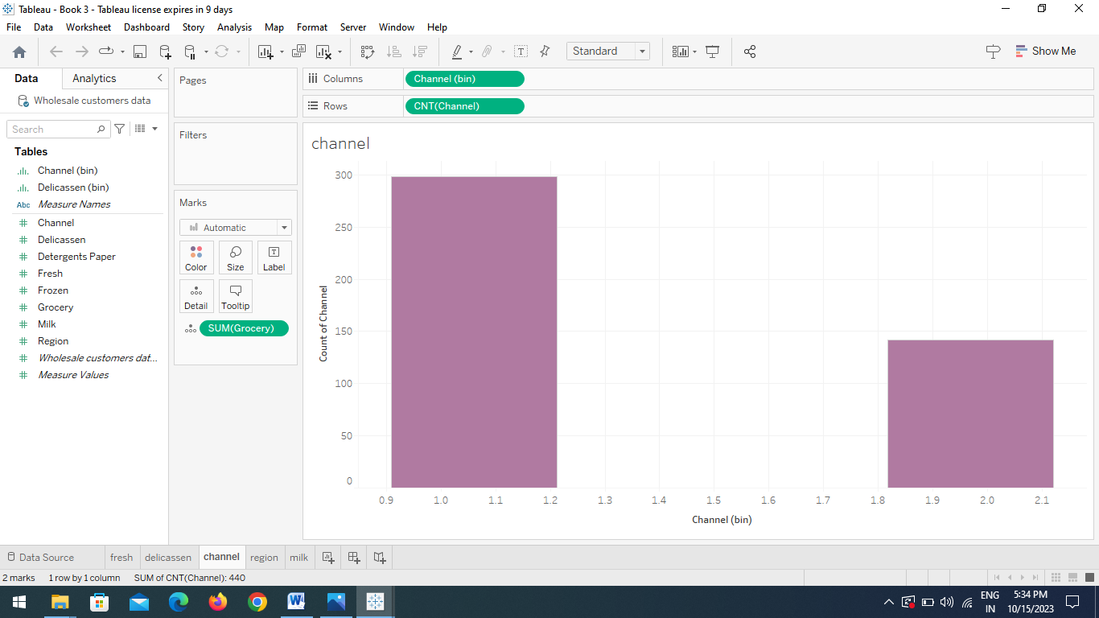

3.3 Story

3.4 Performance Testing

. Amount of Data rendered to Tableau:

The volume of data presented in Tableau is directly influenced by the dimensions of the dataset.

. Utilization of Data Filters:



. No of Visualizations/Graphs:

1.Marketing

2.Region

3.Frozen

4.Measurement

4. ADVANTAGES & DISADVANTAGES

4.1Advantages

Visual clarity: Tableau’s visualizations provide a clear and intuitive way to understand complex data ,facilitating better comprehension of spending behavior and growth opportunities.

Interactive Exploration: Tableau’s interactive features allow users to explore data dynamically, encouraging a more thorough and customized analysis.

Time Efficiency: The tool enables quick data analysis and visualization, saving time in comparison to traditional methods, thus fostering timely decision-making

4.2 Disadvantages

Learning Curve: Tableau has a learning curve, and users who are not familiar with the tool may require training to use it effectively, potentially slowing down the implementation process.

Cost of Licensing: Tableau licensing costs can be relatively high, especially for larger enterprises, which may pose a financial challenge for some organizations.

Data Security Concerns: Handling sensitive market data requires robust security measures. If not properly configured, Tableau deployments may pose data security risks.

5.APPLICATIONS

The application of “Unveiling Market Insights: Analyzing Spending Behavior and Identifying Opportunities for Growth using Tableau” spans across various business domains and functions, offering valuable insights for strategic decision-making. Here are some key applications:

Market Segmentation

Product Performance Analysis

Geographical Expansion

Customer Journey Mapping

6.CONCLUSION

The “Unveiling Market Insights” project successfully utilized Tableau to analyze spending behavior, identify opportunities for growth, and provide actionable insights for strategic decision-making.

This project underscores the importance of leveraging advanced analytics tools like Tableau to unlock the full potential of data, transforming it into a strategic asset for organization in a rapidly evolving market landscape.

7.FUTURE SCOPE

The future scope of Unveiling Market Insights using Tableau is likely to be characterized by advancements in AI, real-time analytics, data security, and improved user experiences.

8. APPENDIX

A. Source Code: